**Nama: Rosmalinda Marbun**

**MID-TES MSIB 6 Kampus Merdeka – Dibimbing.id**

CREATE TABLE employee_table (

employee TEXT NOT NULL,

salary INTEGER

);

INSERT INTO employee_table (employee, salary) VALUES

('Alice', 11),

('Benn', 43),

('Charles', 33),

('Dorothy', 55),

('Emma', 22),

('Franklin', 33);

SELECT DISTINCT salary

FROM employee_table

ORDER BY salary DESC

LIMIT 1 OFFSET 2;

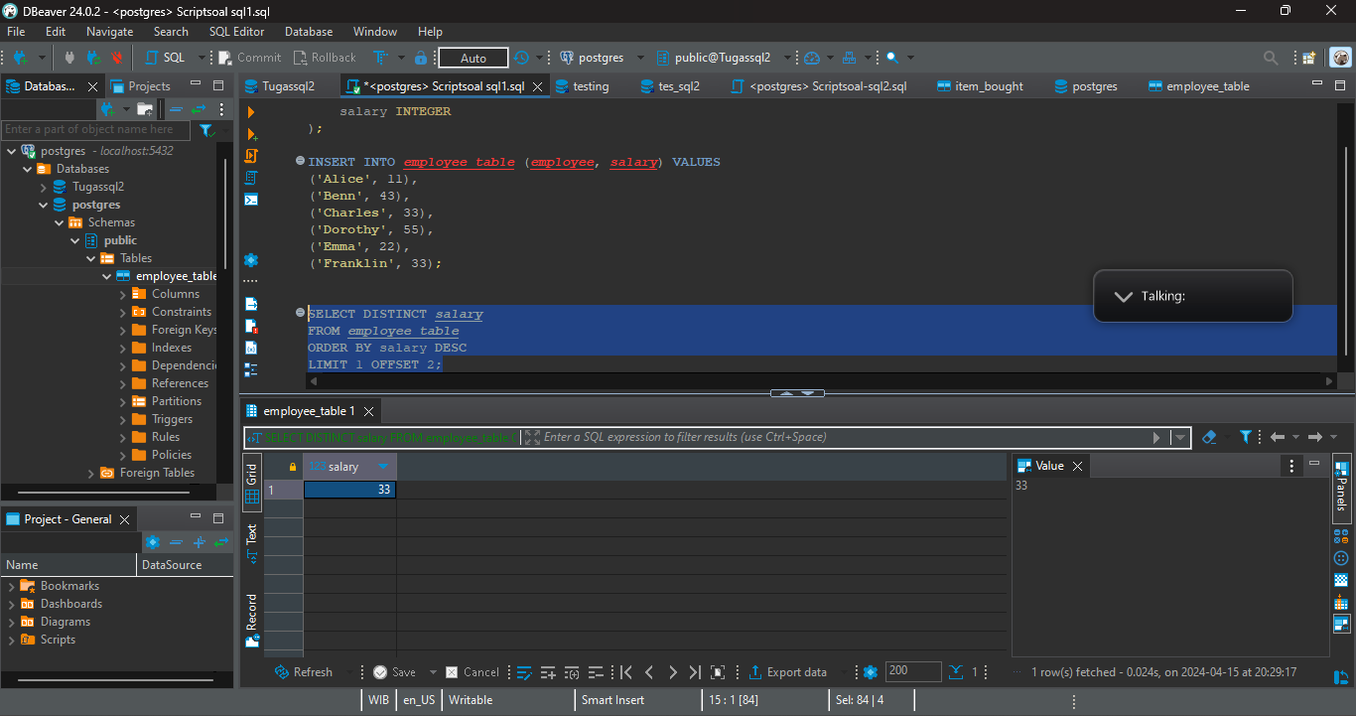

Tabel sql 1

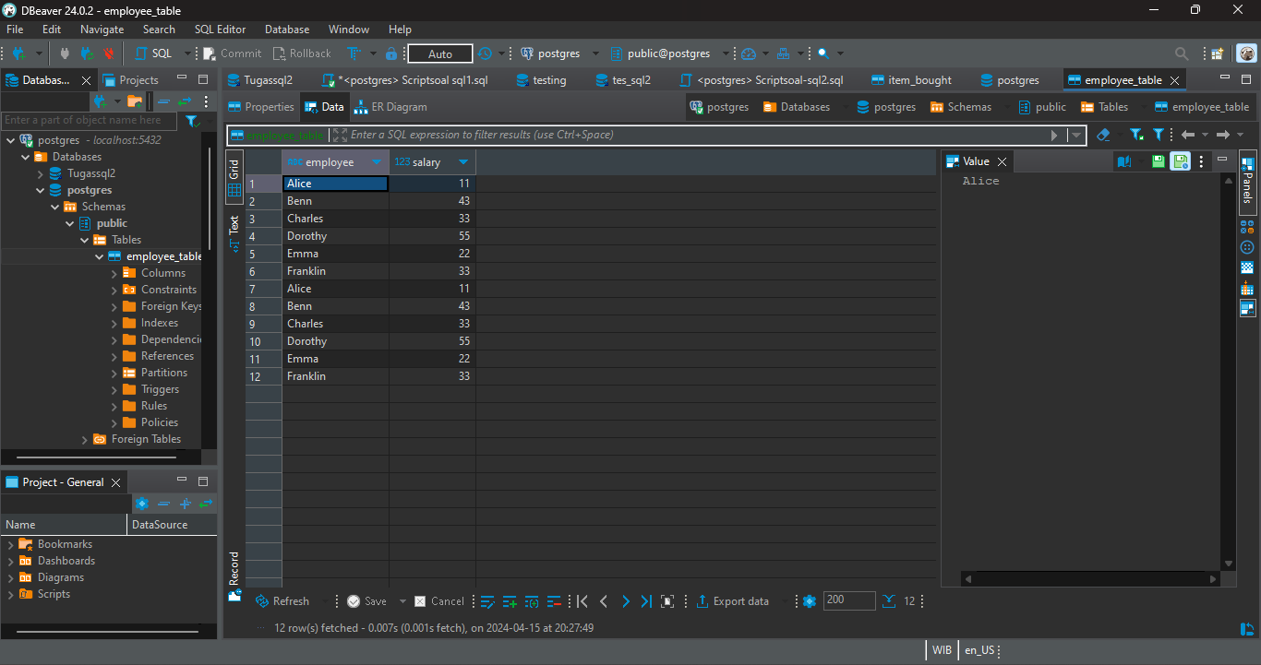

**CREATE** **TABLE** item_bought (

buyer **TEXT** **NOT** **NULL**,

item **TEXT** **NOT** **NULL**

);

**INSERT** **INTO** item_bought (buyer, item) **VALUES**

(**'A'**, **'Asus'**),

(**'B'**, **'Lenovo'**),

(**'C'**, **'Lenovo'**),

(**'D'**, **'Acer'**),

(**'E'**, **'Acer'**),

(**'F'**, **'Acer'**);

**SELECT** item

**FROM** (

**SELECT** item, **COUNT**(*) **AS** *total*

**FROM** item_bought

**GROUP** **BY** item

) **AS** *counts*

**WHERE** *total* != (**SELECT** **MAX**(*total*) **FROM** (

**SELECT** **COUNT**(*) **AS** *total*

**FROM** item_bought

**GROUP** **BY** item

) **AS** *subquery*)

**AND** *total* != (**SELECT** **MIN**(*total*) **FROM** (

**SELECT** **COUNT**(*) **AS** *total*

**FROM** item_bought

**GROUP** **BY** item

) **AS** *subquery*);

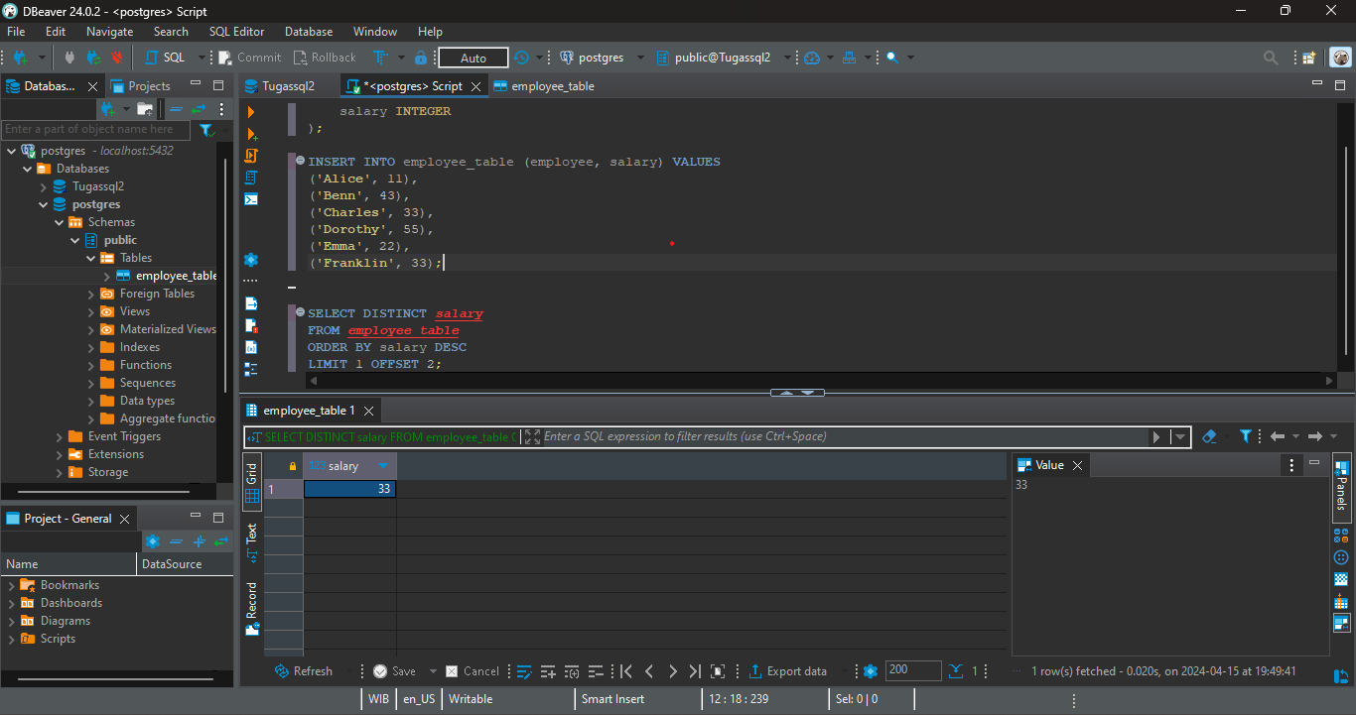

Tabel Soal 2

